Wendover Badminton Club Court Booking User Guide
Contents
Pre-Booking User Guide 1
How to Register 2
Booking a Space at Club Night 4
The Waiting List 7
Amending or Cancelling a Booking 8

Pre-Booking User Guide

This guide shows the steps required to register and reserve your place at club night each week.
The booking system can be accessed by using the following link
www.supersaas.co.uk/schedule/WendoverBC/Court_Booking
www.supersaas.co.uk/schedule/WendoverBC/Court_Booking
If you have any problems using the system, please send an email to enquiries@wendoverbc.org

How to Register

- Click “Create a new user account”
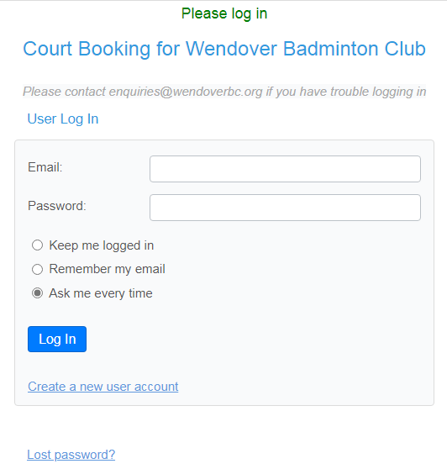
- Complete the New User form with
  - A Valid email address (note- this will be your login name)
  - Create a password
  - Your full name
  - Your phone number
  - Your mobile number (optional)
Click “Create” once you have completed the form
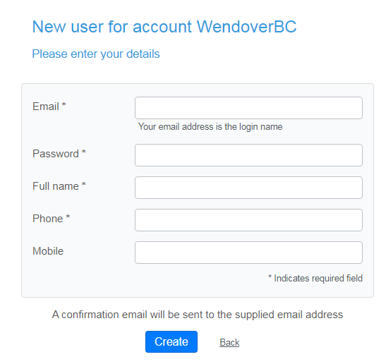

- An email will be sent to you requiring you to click a link to confirm you have entered a valid email address
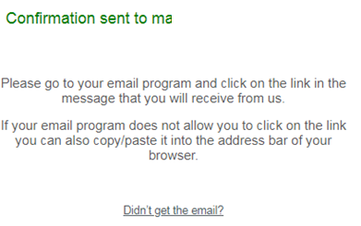
- Go to your email
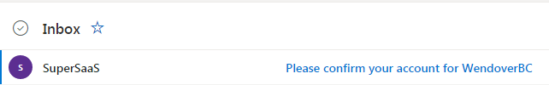
- Click the link in the email to confirm your registration.

Booking a Space at Club Night

- Enter your email address and password on the login page
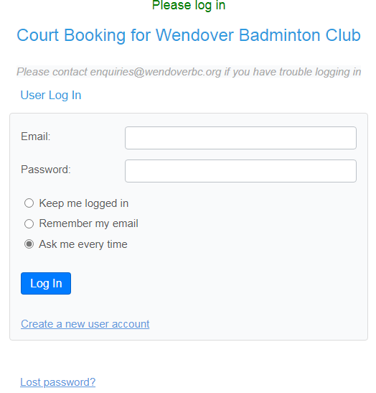
- Ensure you are looking at the correct week, then select the Junior club from the calendar
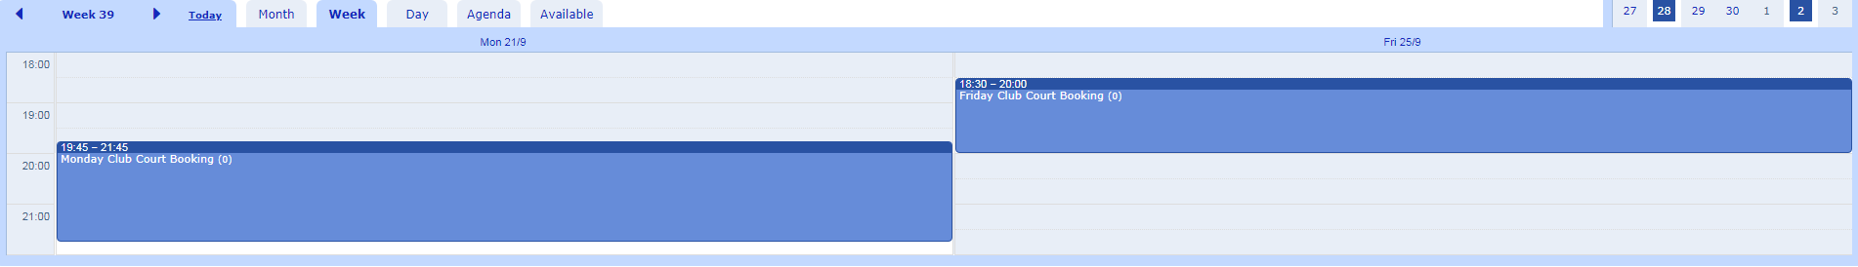
- Click on New Attendance
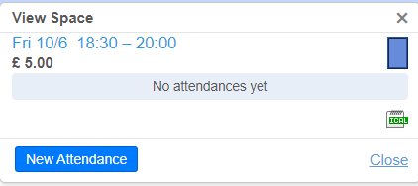

- Ensure your full name and phone number is completed in the form.
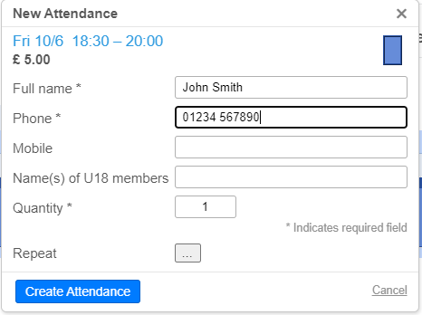
If you are booking on behalf of one or more Under 18 members, please enter their names in the appropriate field and ensure you change the Quantity field to indicate how many spaces you are booking.
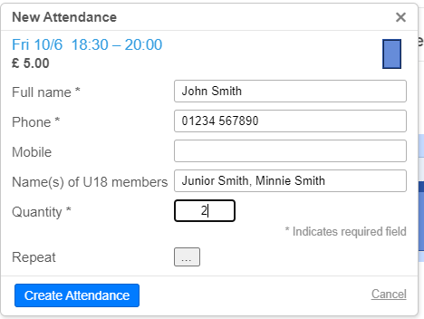

- If you wish to book for more than one week, click on the 3 dots next to Repeat
This will give you the option to select which dates you are booking for. Alternatively you can select the “All” button to book all available weeks.
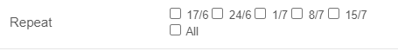
- Click on Create Attendance to move to the booking summary screen.
- The summary screen will show the summary of your booking. Click on Pay Now at the bottom of the screen to transfer to the payment section. If the details are not correct, click Cancel Attendance and start again.
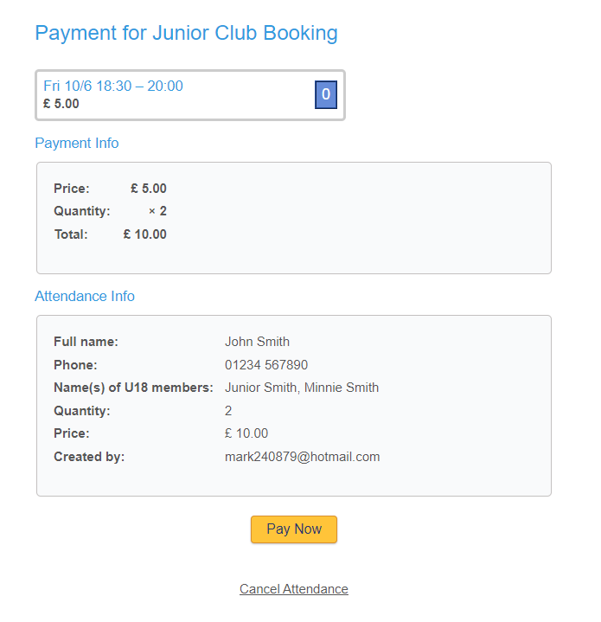
- Once you click Pay Now, you will be taken to the Paypal screen. If you have a Paypal account you can login and make a payment inside Paypal. Alternatively you can choose to pay by debit or credit card by clicking the button. Again, if you do not wish to proceed you can cancel the transaction by clicking Cancel and Return to at the bottom of the screen.
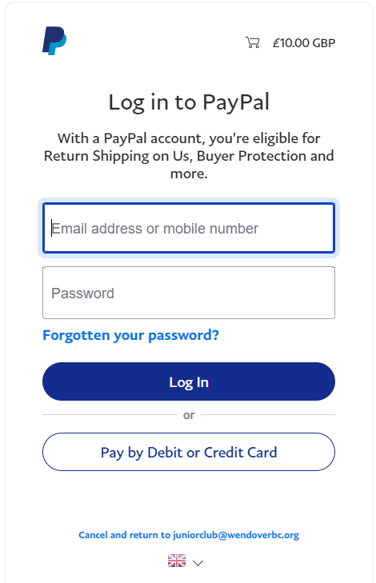

Once the payment has been transacted you will be taken back to the SuperSaas system where a confirmation screen will be shown.
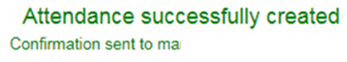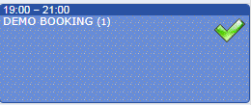

- You will receive an email confirmation of your booking. If you do not receive this email, please check your Junk folder and add noreply@supersaas.com as a safe sender.
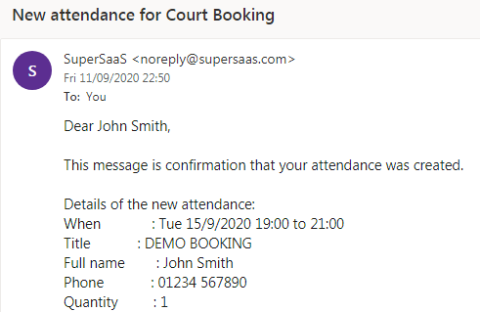

The Waiting List

There is a strict capacity of 24 players at each club night. If a night is fully booked, you will not be able to reserve a space. Instead, you will have the opportunity to add yourself to the Waiting List.
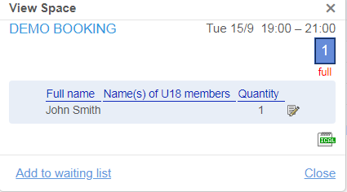
This is exactly the same process as for reserving a space and you will not be taken to a payment screen.
You will be sent a confirmation email showing that you are on the Waiting List.
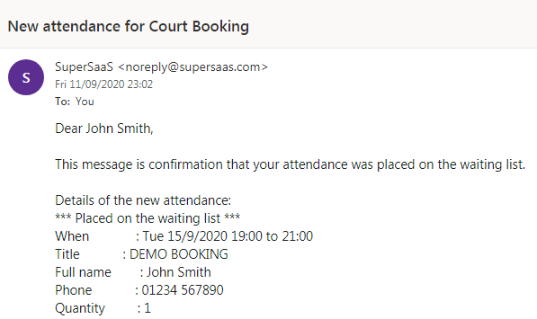
If there is a cancellation from another member, the first person on the waiting list will receive an invition to make a payment and will be added to the court booking and a confirmation email sent
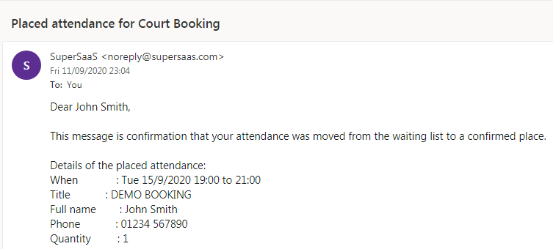

Amending or Cancelling a Booking

- To amend or cancel a booking, either click on the appropriate booking inside the calendar
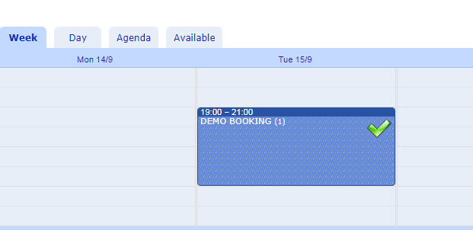
Or click on Agenda then Edit
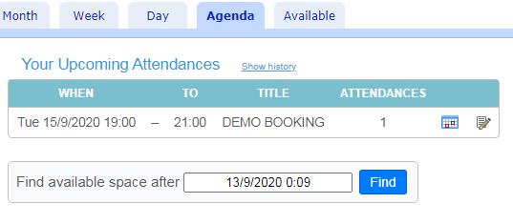
- Click the Edit button inside the booking
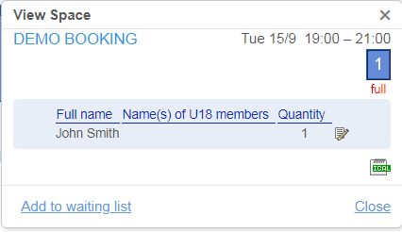

- You can now either amend the details of your booking and click Update Attendance, or cancel your booking by clicking the Rubbish Bin icon.
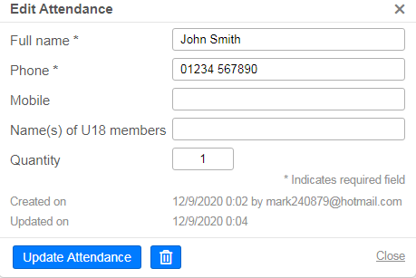
You will be sent a confirmation email of the amendment or cancellation
